**RESUME**

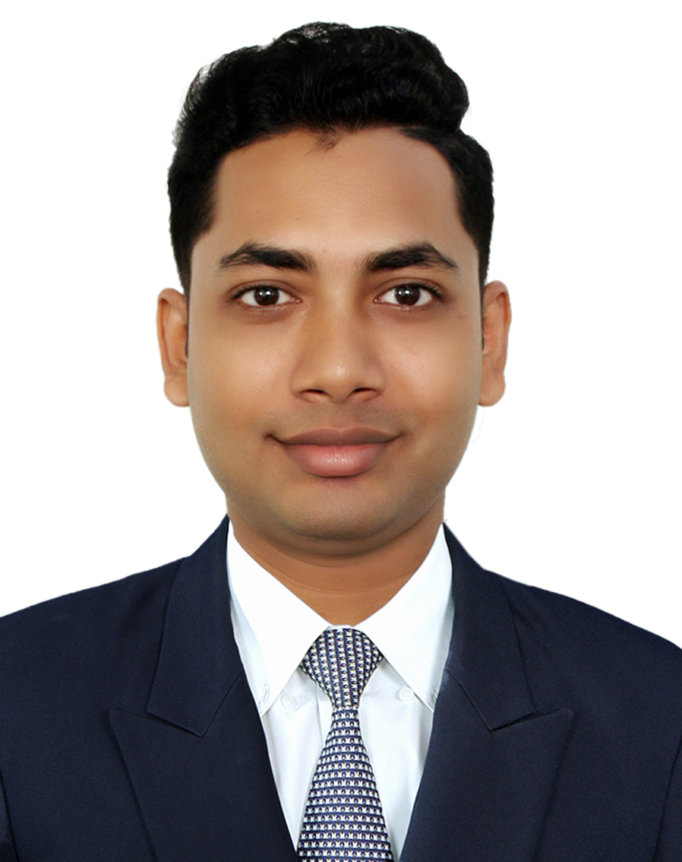

**Of**

**Javed Hasan Tuhin**

**Mobile No: +8801722557933**

**Email:** [**javedtuhin15@gmail.com**](mailto:javedtuhin15@gmail.com)

**Career Objectives**

Attainment of maximum value through offering well merited performance and interchanging benefit with the organization. I want to be a perfect working hand of the organization to attain its goal and also build up my career.

|  |  |
| --- | --- |
| Name  Father’s Name  Mother’s Name | Javed Hasan Tuhin  Md. Khalilur Rahaman  Jobayda Rahaman Moni |
| Permanent Address  Present Address  Date of Birth | Uttar Char, Ward- 07, Mehendiganj, Barishal  Holding No: 273\1, Bara Moghbazer, Ramna, Dhaka.  15th December, 1996 |
| Nationality | Bangladeshi |
| Gender | Male |
| Marital Status | Single |
| Religion  Blood Group | Muslim(Sunni)  AB+ |
| NID No | 4607708270 |
| Passport No | BY 0658863 |
| **Desired Employment** | I am enthusiast to work in an Organization where I can contribute my skills and enrich my experiences. |

**Personal Details**

**Educational Qualifications**

|  |  |  |  |  |
| --- | --- | --- | --- | --- |
| **Degree** | **Name of Institution** | **Group/Major** | **Passing Year** | **Obtained CGPA** |
| M.B.A | Stamford University Bangladesh, Dhaka | HRM | 2019 | 3.09 out of 4 |
| B.B.A | Stamford University Bangladesh, Dhaka | HRM | 2018 | 3.00 out of 4 |
| H.S.C | Amrita Lal Dey College, Barishal | Business studies | 2013 | 4.40 out of 5 |
| S.S.C | Barishal Zilla School, Barishal | Business studies | 2011 | 4.25 out of 5 |

**Computer skills & Training**

|  |  |
| --- | --- |
| Microsoft office | MS Word, MS Excel, MS Power Point, |
| Graphical Software | Adobe Photoshop |
| Internet | Faster Browsing |

|  |  |
| --- | --- |
| * **Present** | Trainee Assistant Officer  Retail & Sme Banking.  Irish Nurjahan Tower, EBL Shantinagar Branch,104 Kakrial Dhaka. |
| * Past | Account Service Executive  BRAC Bank Head Office, Anik Tower 220/B, Tejgaon, Dhaka. |

**Job Details**

**Language Proficiency**

|  |  |  |  |  |
| --- | --- | --- | --- | --- |
| **Language** | **Reading** | **Writing** | **Speaking** | **Listening** |
| Bengali | High | High | High | High |
| English | High | High | High | High |

Hindi Low Low High High

**Traits**

* Good presentation ability
* Capable of adopting in different type-of environment
* Positive, Helpful and Confident
* Can work Under Pressure.
* Analytical and good conceptual ability
* Strong interpersonal roll and reliable.

**References:**

|  |  |
| --- | --- |
| Choudhury Hafez Shehan  Associated Manager  BRAC Bank Head Office  Anik Tower 220/B, Tejgaon  Dhaka 1208, Bangladesh  hafez.shehan@bracbank.com  Mobile: 01716273758 | Nahreen Quayyum  FAVP/ BM Eastern Bank Limited  Irish Nurjahan Tower,104 Kakrial Mobile: 01819263627  Nahreen.quayyum@ebl-bd.com |

I pledge that all the information presented in this curriculum vitae is correct and authentic.

[ Javed Hasan Tuhin ]